MILESTONE AND ACTIVITY LIST

|  |  |
| --- | --- |
| Date | 26 OCTOBER 2022 |
| Team ID | PNT2022TMID40091 |
| Project Name | Airlines Data Analytics for Aviation Industry |

**Activity List:**

|  |  |  |  |
| --- | --- | --- | --- |
| Project Name | Airlines Data Analytics for Aviation Industry | Date | 26-10-2022 |
| Team ID | PNT2022TMID40091 | Team Members | 4 |

|  |  |  |  |  |
| --- | --- | --- | --- | --- |
| Activity Name | Activity Number | Activity Description Tasks Assigned | | Status |
| Preparation Phase | 1 | 1. Access the resources in project dashboard. 2. Explore the dataset provided in workspace. 3. Create GitHub account & collaborate with Project Repository in project workspace. 4. Set-up the prerequisites for the   project. | JANANI.M  SWAPNA.K  SWETHA.M  SWETHA.B | Completed |
| Ideation Phase | 2 | 1. Literature survey relevant to the selected project. 2. Preparation of Empathy Map to identify the user pros and cons. 3. List the ideas by organizing the brainstorming session and prioritize the top 3 ideas based on the feasibility   & importance. | JANANI.M  SWAPNA.K  SWETHA.M  SWETHA.B | Completed |

|  |  |  |  |  |
| --- | --- | --- | --- | --- |
| **Project Design Phase-I** | 3 |  |  |  |
| Proposed Solution | 3.1 | Preparation of proposed solution document, which includes the Problem statement , Idea description, novelty,feasibility of idea, business model, social impact and scalability  of the solution. | JANANI.M  SWAPNA.K  SWETHA.M  SWETHA.B | Completed |
| Problem SolutionFit | 3.2 | Prepared problem solution fit document which have designed a value proposition that addresses the customers’ job, pros and cons to the  particular application. | JANANI.M  SWAPNA.K  SWETHA.M  SWETHA.B | Completed |
| Solution Architecture | 3.3 | Develop effective architecture for the proposed solution which provides ground for application development projects. | JANANI.M  SWAPNA.K  SWETHA.M  SWETHA.B | Completed |
| **Project Design Phase-II** | 4 |  |  |  |
| Solution Requirement | 4.1 | Identify the Functional and Non- Functional requirements of the proposed solution. | JANANI.M  SWAPNA.K  SWETHA.M  SWETHA.B | Completed |
| Customer Journey | 4.2 | Preparation of customer journey map to understand the user interactions  which describes the stages that the customer experiences over time. | JANANI.M  SWAPNA.K  SWETHA.M  SWETHA.B | Completed |
| Data Flow Diagram and User stories | 4.3 | Generate Data flow diagram for the Project which maps out the flow of information for the application. | JANANI.M  SWAPNA.K  SWETHA.M  SWETHA.B | Completed |
| Technology Architecture | 4.4 | Develop effective technical architecture for the proposed solution which describes the logical software and hardware capabilities that are  required to support the development of the application. | JANANI.M  SWAPNA.K  SWETHA.M  SWETHA.B | Completed |

|  |  |  |  |  |
| --- | --- | --- | --- | --- |
| **Project Planning Phase** | 5 |  |  |  |
| Milestones & Activity List | 5.1 | Prepare Milestone and Activity list of the project. | JANANI.M  SWAPNA.K  SWETHA.M  SWETHA.B | Completed |
| Sprint Plan | 5.2 | Prepare Sprint Delivery plan of the project | JANANI.M  SWAPNA.K  SWETHA.M  SWETHA.B | Completed |
| **Project Development** | 6 |  |  |  |
| Delivery of Sprint-1 | 6.1 | Implement the working with dataset | JANANI.M  SWAPNA.K  SWETHA.M  SWETHA.B | In Progress |
| Delivery of Sprint-2 | 6.2 | Implement the working with dataset | JANANI.M  SWAPNA.K  SWETHA.M  SWETHA.B | In Progress |
| Delivery of Sprint-3 | 6.3 | Implement the data virtualization | JANANI.M  SWAPNA.K  SWETHA.M  SWETHA.B | In Progress |
| Delivery of Sprint-4 | 6.4 | Implement the data virtualization- final delivery | JANANI.M  SWAPNA.K  SWETHA.M  SWETHA.B | In Progress |

**Milestone Timeline Chart:**

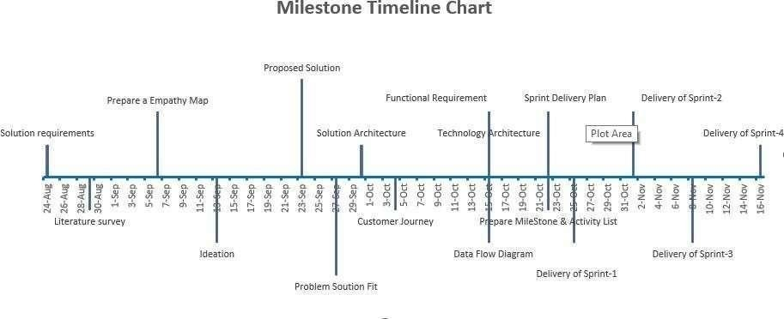A milestone schedule, or milestone chart, is a timeline that uses milestones to divide a project schedule into major phases. A milestone chart is a way to visualize the most important steps of our project. Each milestone the team achieves brings us closer to completing the project. As a result, milestones provide a sense of accomplishment and show the team how the work they’re doing contributes to the overarching project objective.